2024 MEMBERSHIP PARAFED OTAGO

Name:
Address:
Phone Number/ Mobile:
Email Address:
Date of Birth: Ethnicity:
Disability:
Classification (if known):
Sports currently involved in:
Other sporting and recreational interests:
Additional Information:
Emergency Contact Name:
Emergency Contact Number:
ParaFed Otago Member □ ParaFed Otago Volunteer/ Official □ ParaFed Otago Supporter □
(Circle one)
Payment of $40 Is Enclosed. YES / NO
*As a volunteer, event official or first-time member no payment is required.
I am happy for Parafed to take and use pictures/images of me. YES / NO
Signed: Date:

ParaFed Otago has a range of sporting equipment available to assist members in getting started in an activity. This is to enable members to participate, for a trial period, without having to find funds to purchase their own equipment. Our equipment is available for loan to ParaFed Otago members at no charge. Members are responsible for maintenance to keep equipment up to original standard.

For more information or to borrow a piece of equipment please contact: sdo@parafedotago.co.nz

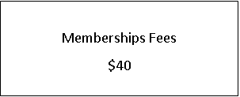
Please return your form and Payment to:
Connor Dann; Sports Development Officer,
ParaFed Otago
40 Logan Park Drive 9054
Or pay the total amount into: 03 0903 0387437 00

